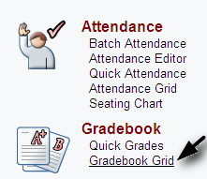
Accessing the Gradebook
- Log into Go Portal
- Click Gradebook Grid

Tabs run across the top. In most cases, each tab is a different class period. EOCT classes have more that one tab for each period.

Student Demographics
If you hover over a student’s name, a short profile of that student will display.
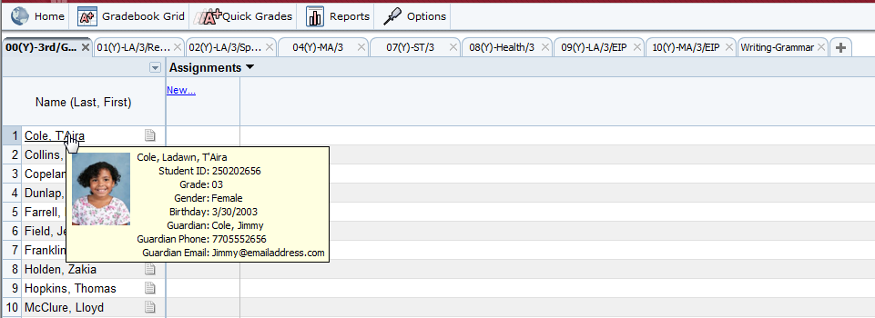

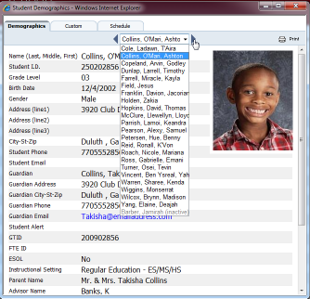
Click on the student name to display more information.
Press the left/right arrows to move to other students. You can also click in the drop down to view and select specific students.

Parent Information in Student Demographics pulls from the first 2 parents that are listed in SASI. *Other than the information you see here, student information is available on the Student Profile link under the “About Students” heading in the Go portal.

When blue email links are accessed, this will pull up the default email program for that computer. If accessing this from home, teachers will want to be careful because their home email program may open up (Outlook, Hotmail, etc…)

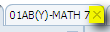
Hiding and Unhiding Gradebook Tabs:
To hide a gradebook tab, click on the x on that tab:

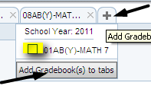
To bring a hidden tab back, click on the “+” sign and check the class you would like to see. Choose “Add Gradebook(s) to tabs”.

Class Options
To access class options, click on the “Options” tab at the top of your gradebook:

Below are explanations for each tab you see:
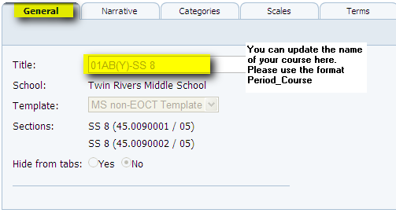
General: You can update the course tab name here. Please keep the format of your naming convention Period_Course Name_Tchr Name (ex. 02_Life Science_Smith) so your tabs stay in order of your day.

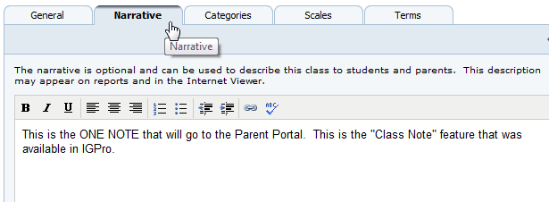

Narrative
This is the note area that will show in the Parent Portal. This is like the “Class Note” feature that was available in IGPro.

Categories
Please note that these are set on the GCPS mandated grading category weights for this year (Classroom: 40%, Summative: 50%, and Final Exam 10% for all non-EOCT courses; Classroom: 35%, Summative 45%, Final Exam 20% for EOCT courses). If your department decides to change the name of a category or break a category up into more than one, please check with your AP to approve and then make the changes to your categories as follows:

- Click on either “Edit” to update a category already there, or “New Category” to create a new one.
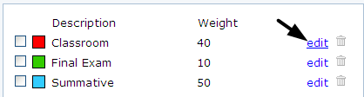
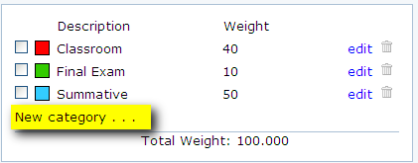

- Update the Description (Name), color (optional), and percent weight for the category. Make sure you click on SAVE when you are done.
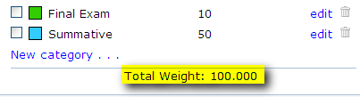
Beware: The Total Weight can go over 100 without an error message…you MUST make sure your categories are correct and add up to 100%!!

- If categories and weights changed need to be applied to other class periods, you can copy them to your other classes by checking the box next to each category and click on COPY. On the next screen, click on the classes you want to have these changes and click on SAVE. *You will still need to go to EACH NEW TAB that you copied the categories to and delete the template categories that were in there before.
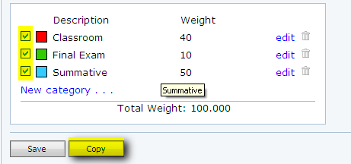
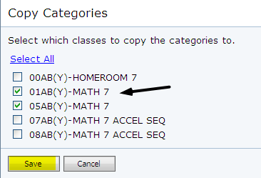

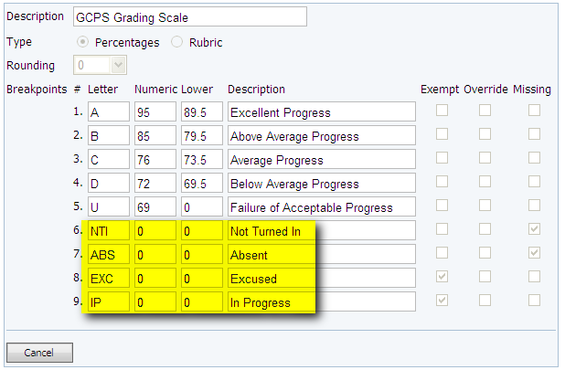
Scales
Special Scores are now determined by the county. Please note that these are the ONLY options. NTI and ABS will average in a zero, EXC and IP will not be averaged into the grade.

Creating a New Assignment
Click on “Gradebook Grid”

Entering Tasks
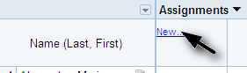
Click New

The following box will appear. Fill in all areas.
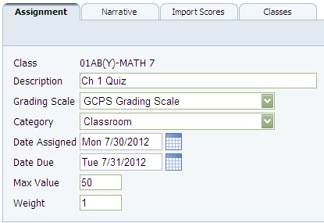

Date Assigned and Due-If dates are set up correctly, it will pull info from the attendance part of Pinpoint and will flag ABSENT next to the assignment for that student.
Max Value – will always be out of 100% no matter what you enter in this box; example if you want to make it out of 20 points and enter 18/20, 15/20, etc…
Weight – IMD strongly recommends leaving this at 1.

Copying the assignment to other classes: Click on the Classes tab and then select which classes to apply the assignment to. Note: This Classes tab is only available when first creating a new task.
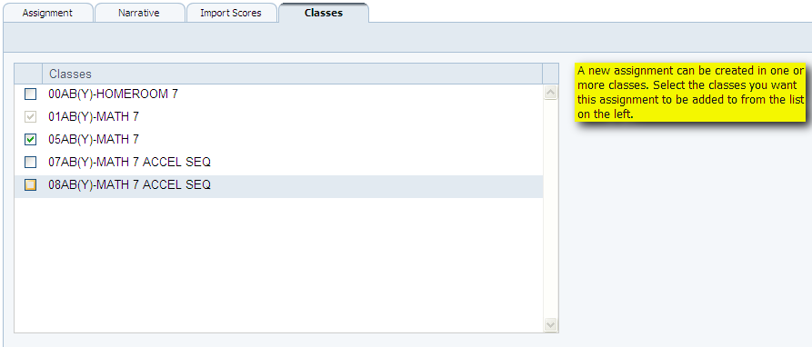

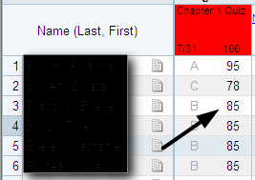
How to Fill a Column With One Grade: You can enter a score, press enter, then press Shift + 8 and hold it down to fill the rest of the column.

Quick Grades
If you click on “Quick Grades” the gradebook will show one assignment at a time. You can enter comments for this assignment at the same time you are entering the grade. These comments will not appear on the Parent Portal, but can be included on Reports.

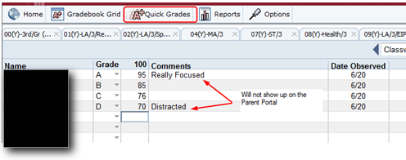

Assignment Score History
Right click on a grade to show who had updated that grade and when.

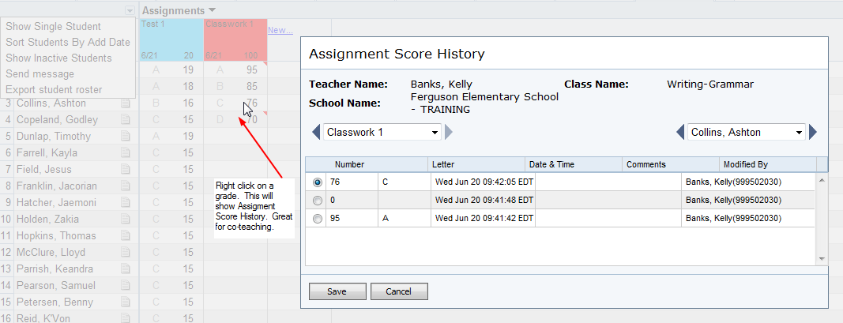

Different Student Views
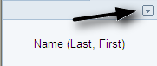
Click on the arrow in the Student Name box. Below are the options you have on this menu:

Sorting Students in a Class: You have two options: you can “Sort By Name” or “Sort Students By Add Date”. You can also show or unshow inactive students here.

Show Single Student View – good for sharing grades with students and keeping others student grades private.
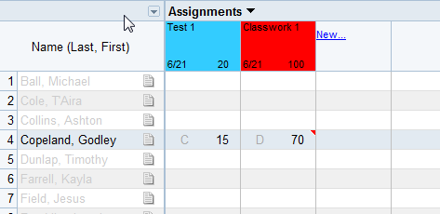
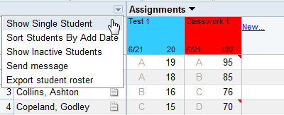
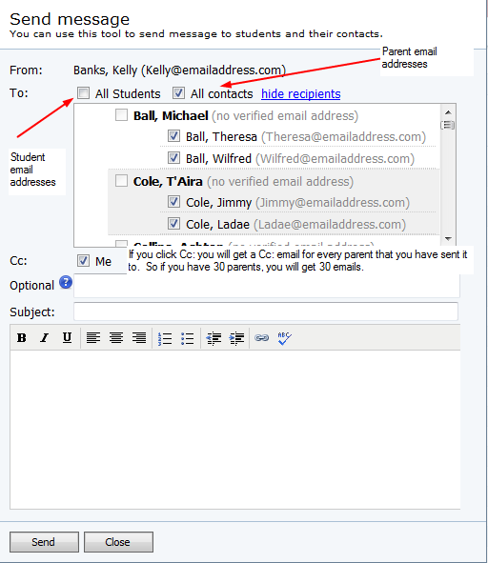
Send Message: A teacher can email parents as well as students if needed from here.

If you click the Cc: box, you will get an email for every parent that you have send an email to. In other words, if you send 30 parents an email, you will get 30 Cc: emails.

There is NOT an email log in Pinpoint that keeps track of emails you have sent. However, it’s good practice to keep a record of the emails/communication you have with parents. You can hypersnap the email and keep it if you would like to have only one copy.

Other Gradebook Navigation

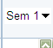
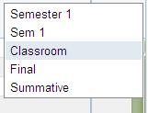
View category averages: You can look at other views of the gradebook by choosing the arrow next to the “Sem 1” on the top right-hand side of the gradebook. When you choose this, you can view the average for your students in just one of your grading categories. You can also see quickly if you have not use a category.

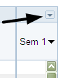
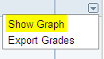
See a graph of your students’ grade progress: Click on the little arrow ABOVE “Sem 1” to access a few other options. Once you have grades in the gradebook, you can see a line graph of your students’ progress if you choose “Show Graph”.

General Notes: When working in the gradebook, yellow and green are good colors; pink is bad (means something didn’t work).

Teachers are the ONLY ones that can change grades in their gradebook. Admin and LSTC can view items, but can’t change items. There is a huge push from the county about teachers being the only keeper of their gradebook!
Attendance
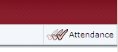
You can toggle quickly between Attendance and Gradebook by clicking this button in the top right-hand corner:

A green check next to the class period name tab shows when you have taken attendance.
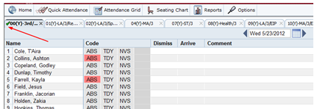
To mark a student absent, tardy, or NVS, just click on the code for the student; add comments if you would like.

To mark all students present, click the All Present button
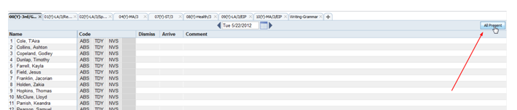

Seating Chart
You can create a seating chart with pictures of your students and even put a teacher desk location. This is a great resource to print and leave a substitute! Also, you can take attendance straight from the seating chart if you like.

To create the seating chart:
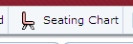
- Click on “Seating Chart” when you are in the Attendance Grid.

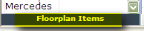
- Click and drag the student pictures onto the grid. If you would like to add a teacher desk, click on the “Floorplan Items” under the student pictures.
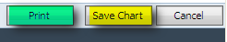
- Click on “Save Chart” . Once you have done that you can either print it as well.
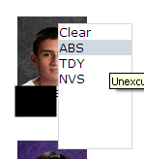
- Taking Attendance from the seating chart: Click on a student and then choose the correct code. You also have the “All Present” option on the top right-hand corner of the seating chart.

